CIS40A Lab 8: Packet Tracer – Router and Switch.

In this lab, we will be using Packet Tracer, which is a simulator for Cisco appliances. Using Packet Tracer will help you become familiarized with network diagrams, configuration in CLI and GUI. You will need to sign up for free access to Introduction to Packet Tracer course, which provides you details on Packet Tracer. You will be able to download Packet Tracer through the free course access.
*If you already have a Cisco Academy account, you can login to the account. You can begin this lab following Part C.
Provide necessary screen captures and answers in various steps.

Part A: Sign-up for Cisco Academy and Download Packet Tracer
*If you have not registered for NetACad account, complete steps 1 – 4.
- Visit Cisco Academy Packet Tracer course.
- Click Sign Up Today! and English button to sign up for the free course. Cisco requires course registration to access Packet Tracer.
- Fill in the Enrollment form using your school e-mail address, then click Create Account.
- Login your school e-mail and click Activate Account button on the e-mail.

Part B: Download Packet Tracer 8
- Login NetACad website and Resources to download Packet Tracer.
- Click Download Packet Tracer. You should copy the downloaded executable to your USB flash drive so you will have it to use outside of school.
- Open Downloads folder and click the executable file to begin the installation of Packet Tracer.
- Once the installation is completed, open Packet Tracer and begin the next activity.

Part C: Routing in Packet Tracer – Start at this part if you are using classroom PC!
In this lab, we will use the Packet Tracer to configure routers. If you have not downloaded the Packet Tracer app, you will need to register for an account on NetACad. See below steps to obtain Packet Tracer. Complete the procedures as listed in Routing in Packet Tracer section.
- Open Packet Tracer. Login to NetACad. See Part A if you don’t have an account.
- Click Network Devices, then click Routers on the bottom left pane.
- Locate router 1841 and drag it into the workspace.
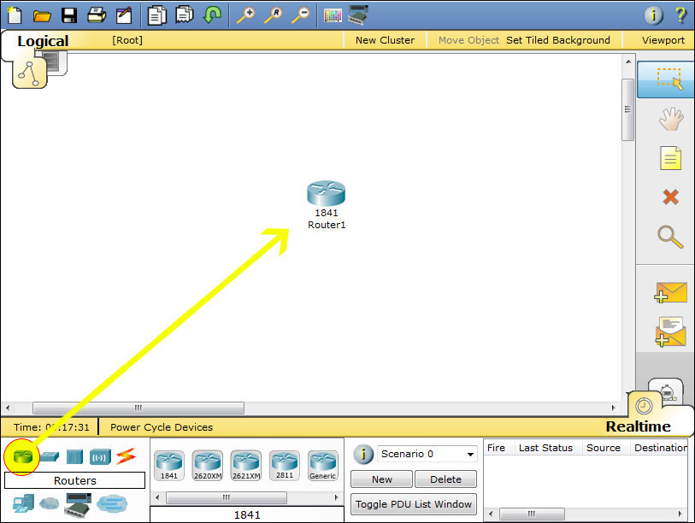
- Click End Devices, locate desktop PC and drag it to the workspace.
- Repeat step 4 to add another PC to your topology.
- Click Connections (lightning bolt), then select copper crossover cable (dotted line) to connect the PC to the router. (FastEth – FastEth). Click the PC0 and select FastEthernet. You will notice that although a link is established, it is not functional. Once the router is configured correctly, the red dots will turn green to indicate the devices are able to communicate.
- Do the same operation to PC1, only this time connect the cable to FastEthernet0/1 since FastEthernet0/0 is already taken by PC0.
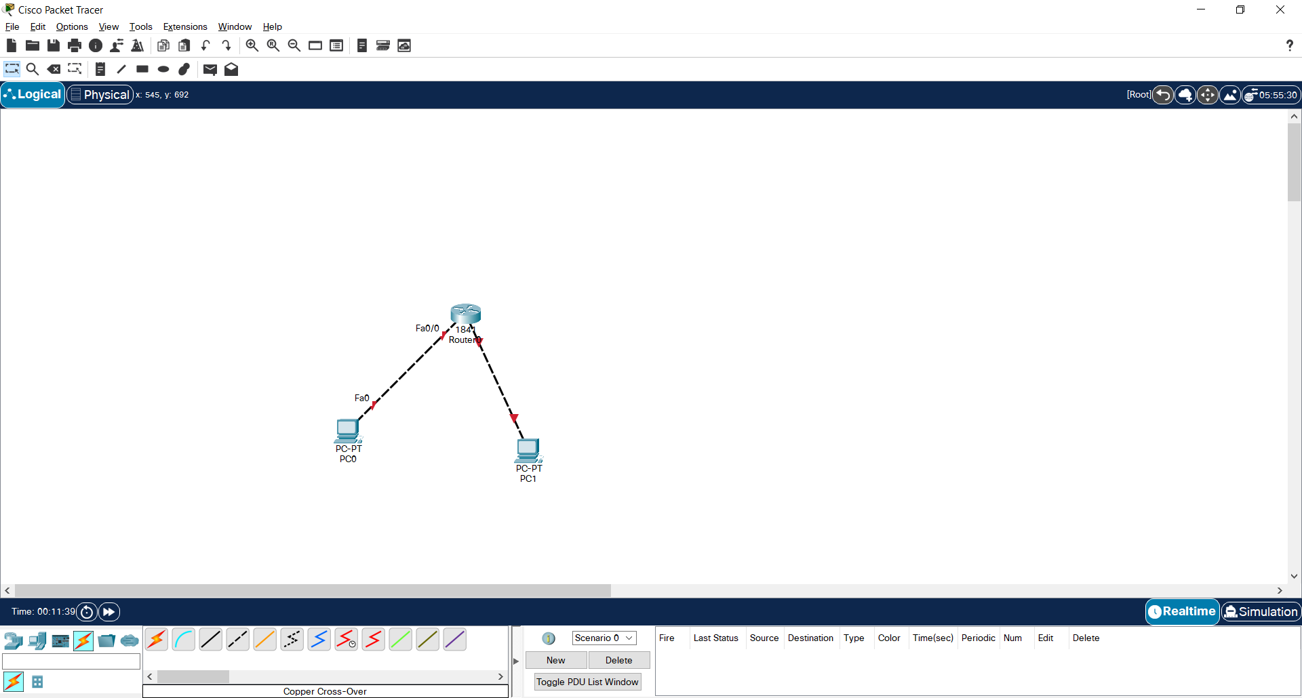

- Verify that the power is on, green on the power button.

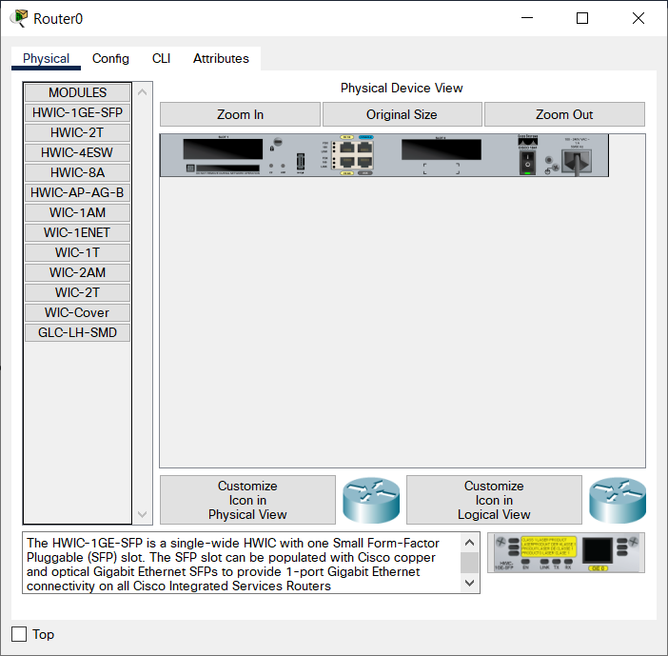

- Click on the CLI tab, and type “yes” to enter the initial configuration.
- When prompted with basic management setup, type “yes”.
- Enter the hostname: R1
- Enter enable secret: MyCiscoNetwork
This is the password after you enter the encrypted session.
- Enter the enable password: CIS40A!
- Enter the virtual password: RemoteCiscoR1
- When prompted with configure SNMP, enter no. We will do this after interfaces are enabled.
- Review the interface summary, then enter: FastEthernet0/0 to access the FastEthernet0.
- Type “yes” to configure IP address.
- Enter IP address: 192.168.10.1
- Enter subnet mask: 255.255.255.0
- Enter 2 to save the configuration.
- Press Enter. You should see the hostname as R1>, which is in the user exec mode.
- To change to privilege exec mode, enter command: enable
- Type in the secret password from step # 12.
- We will now change to global configuration mode by using command: config term
- To configure the second interface FastEthernet0/1 use command: interface FastEthernet0/1
- Enter IP address using command ip address 192.168.20.1 255.255.255.0
- To save configuration, use command no shutdown
- To configure SNMP use the command snmp-server community public RO
This command enable Read-only for public.
- To allow private read and write use command snmp-server community private RW
Simple Network Management Protocol (SNMP) is an application-layer protocol that provides a message format for communication between SNMP managers and agents. SNMP provides a standardized framework and a common language that is used for monitoring and managing devices in a network. The Simple Network Management Protocol (SNMP) applications perform the following operations to retrieve data, modify SNMP object variables, and send notifications:
- SNMP Get
- SNMP SET
- SNMP Notifications
See Cisco SNMP configuration support document
- To set static route use command ip route 192.168.10.0 255.255.255.0 10.10.10.2
We set route from 192.168.10.0 network to 10.10.10.2 device.
- To enable route use command ip routing
See Cisco IP Routing Document.
- To use RIP version 2, use command: router rip
Routing Information Protocol (RIP) is a commonly used routing protocol in small to medium TCP/IP networks. It is a stable protocol that uses a distance-vector algorithm to calculate routes.
- Enter the version: version 2
- Specify the list of networks that use RIP using command network 192.168.10.1
- Disabling automatic summarization of subnet routes into network-level routes. This allows subprefix routing information to pass across classful network boundaries using command no auto-summary command
- Exit router configuration mode using command exit or end, type it twice.
- Saving to VRM using command write memory
- To return to the privilege exec mode, use command exit press Enter. Enter: enable
- To display the running configuration, use command show running-config
- Press Enter to view more information.
- To display IP information use command show ip interface brief
Take a screen capture of the CLI and topology (topology should show green connections).
- Click on each PC, then click the Configure tab.
- Enter the router IP address in the Default Gateway field.
- Remove a PC using the Delete button at the top.
- and extend your network and add a switch, a server and PC. Connect the switch to the router using cross-over cable. Connect the PC to the switch using the straight-through cable.
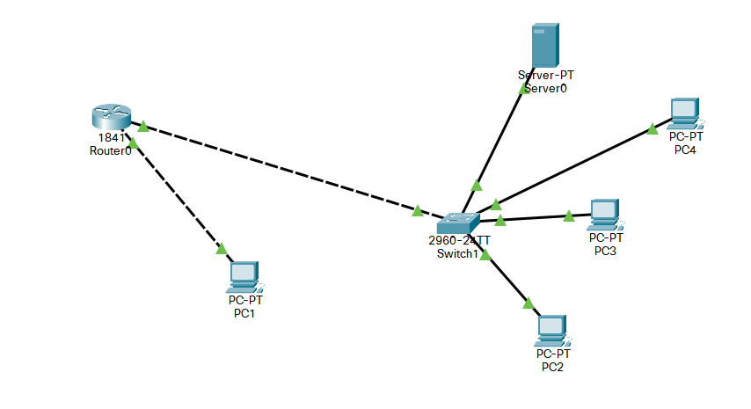
- Use the switch CLI to setup the initial configuration. Use IP address 192.168.10.5 (This switch model does not route as is a layer-2 switch, so you cannot use ip address command in regular port, you must use VLAN. To see VLAN, use “show vlan” in privledged mode. Then, config term --> interface vlan 1, then ip address (ip address) (subnet mask). To see vlan ip, exit twice, then use “shop ip interface”.
- Save configuration and use command to show summary of the switch IP.
- Take a screen capture of the IP configuration information.
- Save the packet tracer file.
- Close Packet Tracer windows.
- Login Canvas and submit a document that contains the lab exercise screen captures.

Part D: Deploying Cabling Services in Packet Tracer
- Download the “Deploying and Cabling Devices.pkt” file from Canvas. *You can also find this file in Chapter 2 of Packet Tracer course on Netacad.
- Open the “Deploying and Cabling Devices.pkt” file.
- The first task in this activity is to practice using the Device-Type Selection Box. The top row of icons represents categories of devices, and the bottom row represents subcategories. Point at the top row of icons slowly and look at the Label box between the rows, the names of the categories will appear. Now point at the lower row icons and you will see their names appear. In this activity we will deploy Switches and PCs. Point at the lower row icons until you see one labeled Switches. Click on that icon and you will see the devices in the Device-Specific Selection Box change.
It now shows the switches available in Packet Tracer.

Deploy two 2960 switches (if you don’t remember how review the previous activity) over the Switch0 and Switch1 labels in the workspace.

- Now click on the End Device category in the Device-Type Selection Box, and deploy six PCs. If you are unsure of which device is the PC just point at the device in the Device-Specific Selection Box and look at the label area below the devices, it should say PC-PT (remember that you don’t have to select the PC icon six times to deploy them, there is a shortcut). Your workspace should now look like this.

- We are now going to connect the PCs to the switches.
Click on the category that looks like a lightning bolt labeled Connections. In the Device-Specific Selection Box, there will appear a series of cable types, select the Copper Straight-Through cable type. Now point at the center of PC0 and click on it. You will see a pop-up menu appear showing the cable connection types. Point and click on the FastEthernet0 selection. Now a wire will appear anchored to the PC. Point at Switch0 and click on it. Another pop-up menu will appear with a much larger set of selections, point at, and click on the FastEthernet0/1 selection. The cable will now be connected and two blinking link lights will appear: one green and one amber. After a while the amber light will turn green for reasons you will understand as you learn about networking.
- We are going to cable all six PCs to the switches.
- Either select the cable each time or use the <CTRL> key just like in first activity. This is the set of connections to be done.
- PC1 FastEthernet0 to Switch0 FastEthernet0/2
- PC2 FastEthernet0 to Switch0 FastEthernet0/3
- PC3 FastEthernet0 to Switch1 FastEthernet0/1
- PC4 FastEthernet0 to Switch1 FastEthernet0/2
- PC5 FastEthernet0 to Switch1 FastEthernet0/3
If you used the <CTRL> key to do multiple copies cancel it by clicking on the cancel indicator.
- Now we need a different type of cable to connect the two switches. Select a Copper Cross-Over cable.
- Click on it and then point at and click on Switch0. From the pop-up menu select the Gigabit0/1 interface near the bottom of the list. Then point at and click Switch1 and select the same interface from this list. The cable will appear and both link lights will be amber but will eventually turn to green after about a minute.

- Save file and take a screen capture of your workspace.
- Answer the following questions:
  - What have you learned about router and switch configuration upon completing this lab in PacketTracer? That you need to be careful and sure about which mode you are in while configuring a router
  - How can you apply these learned concepts in an IT or Cybersecurity career? Knowing how to configure these systems will help to minimize the attack surface.

- Close Packet Tracer and log off Netacad website.
- Login Canvas and submit Lab 8.
- Remove your personal USB and shutdown the PC.

